Chris Beatty

August 10, 2022

Mod 2.2 - Building a Web Page Exercise, Part 1

Validator with errors

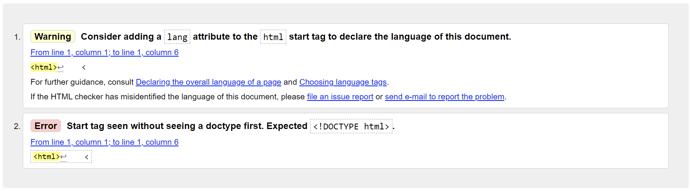

Validator no errors, pt1

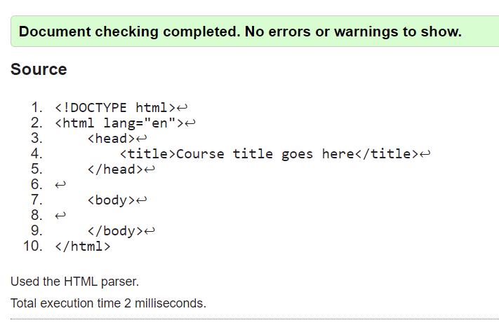

Validator no errors, pt2

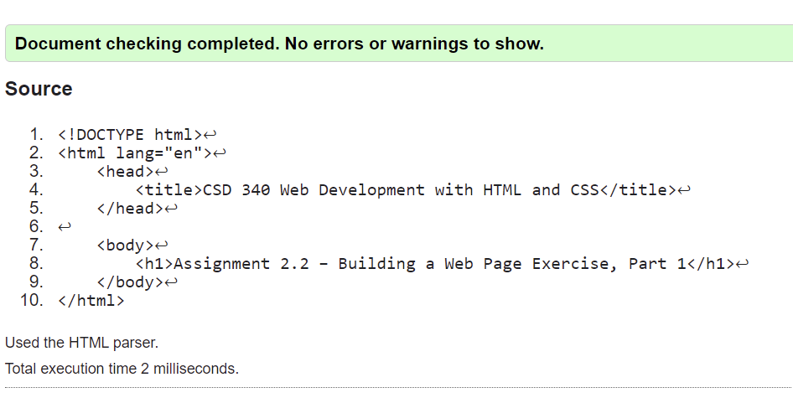

Web browser output

